**Description Document for Web Engineering Lab 6**

**Name: Yousuf Rehan**

**CMS: 429043**

**Class: BESE-13B**

In this lab, I developed an Event Calendar using HTML, CSS and JS. The HTML structure is very simple, and the bulk of the UI is generated through Javascript. Like all my previous labs, I made the design for this in dark mode as well.

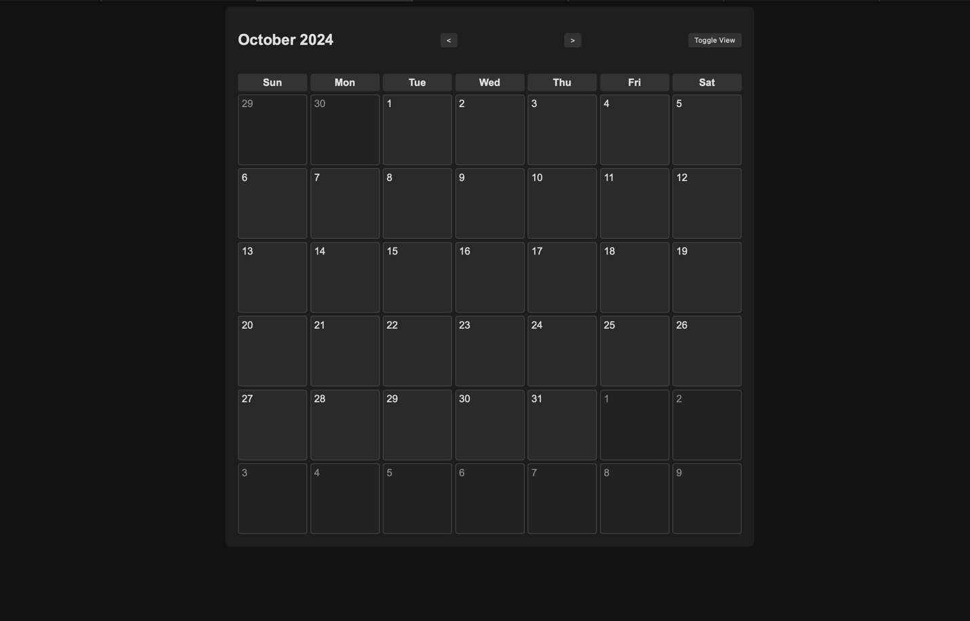

This was a difficult lab. I already have a lot of experience with writing javascript so rendering the UI dynamically was easy. But I hadn’t really used the Date object. So I had to consult W3 school and Mozilla Web Docs quite often. Got a little help from chatgpt as well to understand the Date object and how to use it to get the dates within a certain range. I used CSS grids for the layout. I used HTML DOM Document for most of the javascript functionality.   
  
I followed the specifications laid out in the lab. There are two views; the month view, shown above and the weekly view, as can be seen below:

Going to next week:

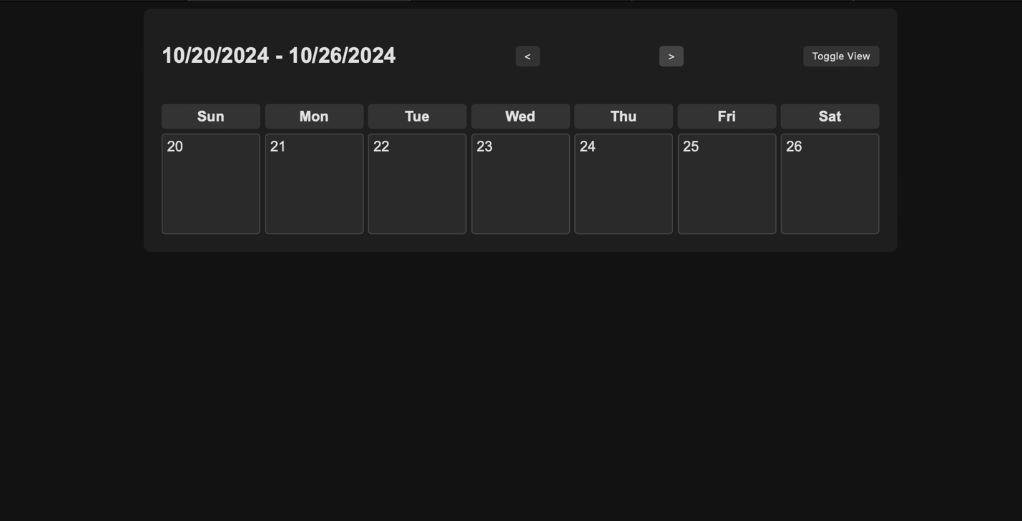

On clicking on a date, a modal pops up using which you can create an event:  
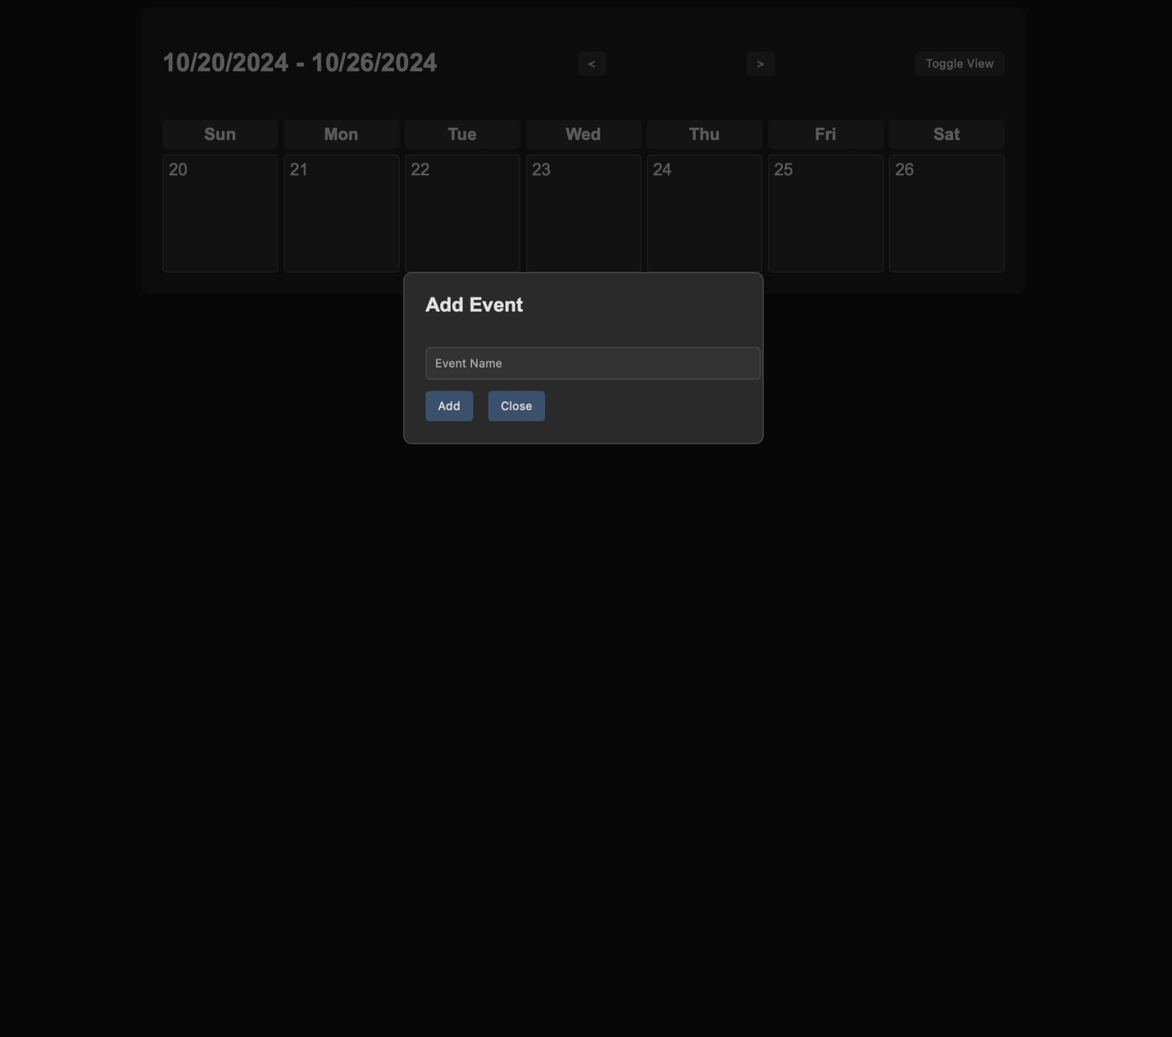

On adding the event, we can see it under the date, like so: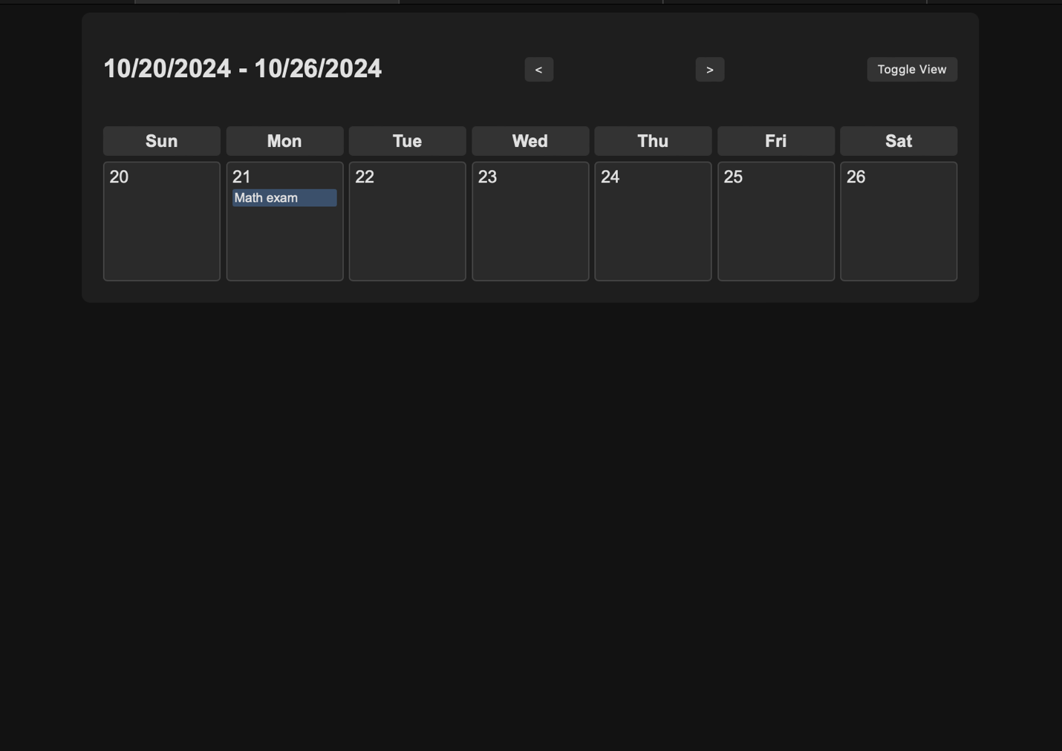

The event is shown under the same date when the view is changed as well. This is because the list of events remains the same:  
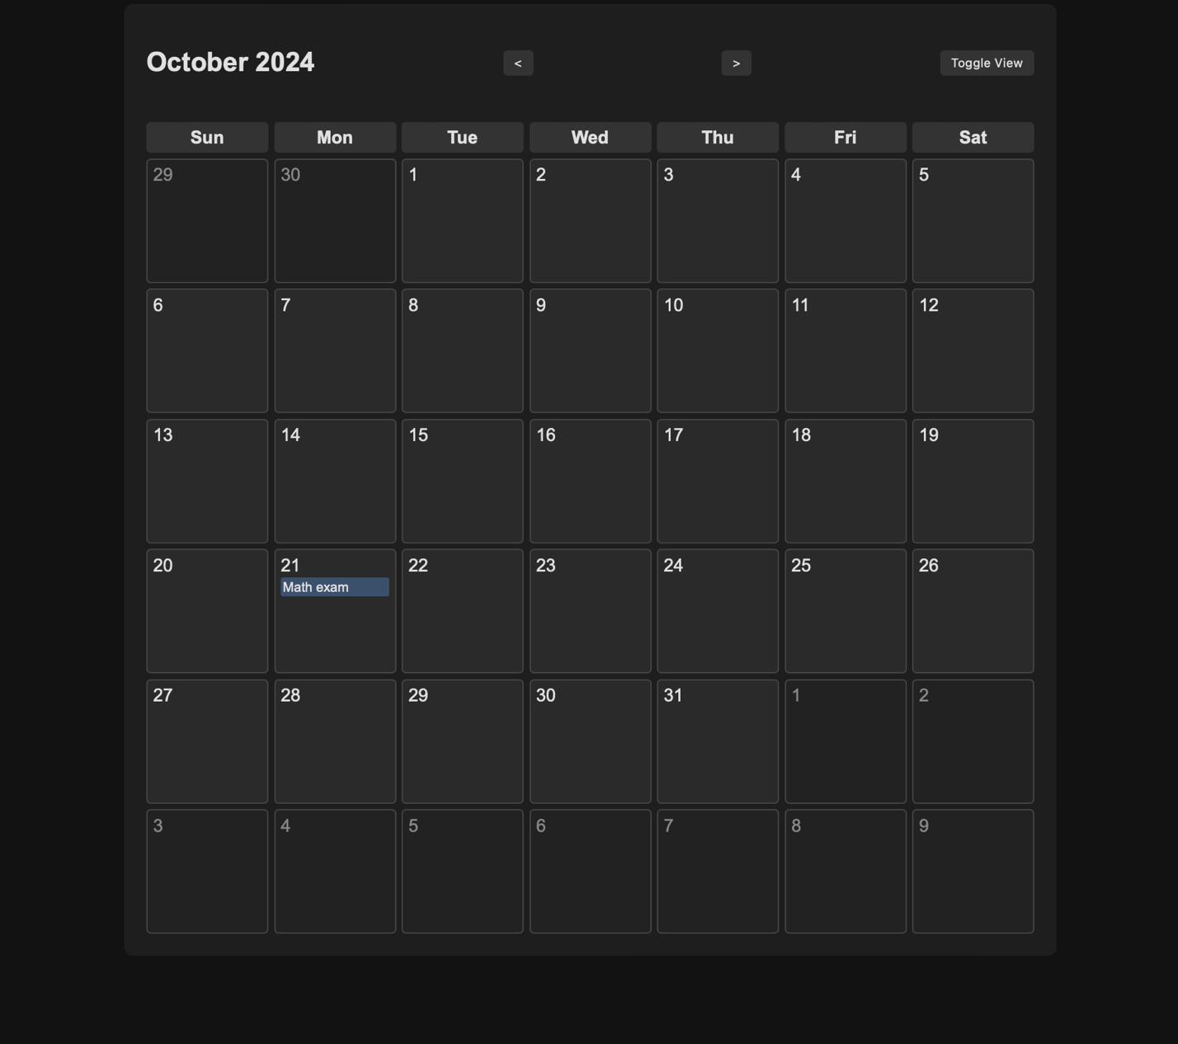

The dates not in the current month are shown in a different color to differentiate them from the dates in the month.

It’s responsive too.

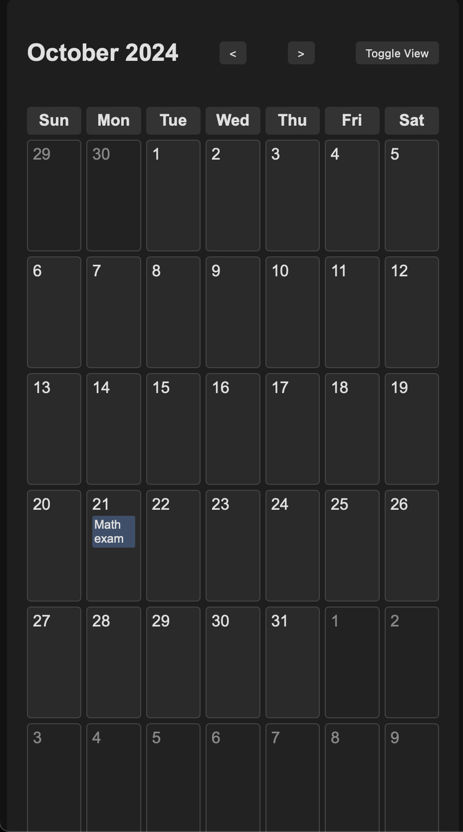

Github link: https://github.com/IronYR/we-lab6